

About us
River Park Toastmasters club was founded in 1991, and is a fun and friendly club with a mixture of talents, speaking experiences, sexes, races, ages, and national origins.

River Park Toastmasters consistently win prestigious awards (such as President’s Distinguished Club) which recognize the efforts of our members in creating a dynamic, engaging and effective Club. Our newer members benefit from the wealth of experience and knowledge from our seasoned members.
River Park Toastmasters

For more information:

Please visit us on the Web at:
riverpark.toastmastersclubs.org

View our RSpace Site at:
workspaces/toastmasters

Toastmasters International at:
www.toastmasters.org

Or Contact
Mary Copeland
Vice President of Membership
Mary.Copeland@state.mn.us
(651) 556-3651

Where Leaders Are Made!

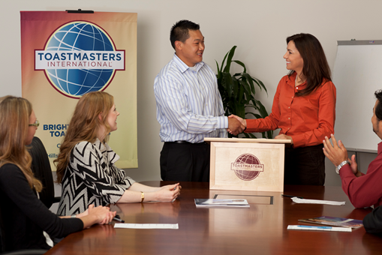
2nd & 4th Wednesdays
12 - 1 PM

Stassen Building
600 N. Robert St.
St Paul, MN 55101

For meeting room numbers, please visit workspaces/toastmasters on RSpace, or http://riverparktoastmastersclubs.org and view our Calendar of Events.

Our Mission
The mission of River Park Toastmasters Club is to provide a mutually supportive and positive learning environment in which every member has the opportunity to develop communication and leadership skills, which in turn foster self-confidence and personal growth.
River Park Toastmasters
River Park Toastmasters
River Park Toastmasters
River Park Toastmasters
River Park Toastmasters

Proven Results
Our club's learn-by-doing program is sure to help you become a better speaker and leader.

- New Member Kits guide you step-by-step through the Toastmaster program

- Complete speeches and leadership projects at your own pace

- Members give encouragement and guidance to help you succeed

- Membership is convenient, and is open to the public

- Department of Revenue employees may use 2 hours of work time per month to attend meetings

Membership is Affordable
- $20 one-time new member fee

- $39 dues every six months

- Department of Revenue employees may receive reimbursement for membership dues

A Typical Meeting
At each River Park meeting, every member has a chance to speak in front of a supportive audience, with either impromptu or scheduled speeches. All speakers receive constructive feedback from other members.

Members also develop their leadership skills by facilitating the meeting, filling meeting roles, serving as club officers, or working within leadership projects.

Visit a Meeting
Visiting a River Park Toastmasters meeting is a fun, no-pressure way to see what our club is all about!
- Guests are welcome as often as they like, free of charge
- No reservations required
- All are welcome to bring their lunch
- Guests are under no obligation to speak, but are welcome to

We meet on the 2nd & 4th Wednesdays from Noon to 1 PM.

Stassen Building
600 N. Robert St.
St. Paul, MN

For meeting room numbers, please visit workspaces/toastmasters on RSpace, or http://riverparktoastmastersclubs.org and view our Calendar of Events

