
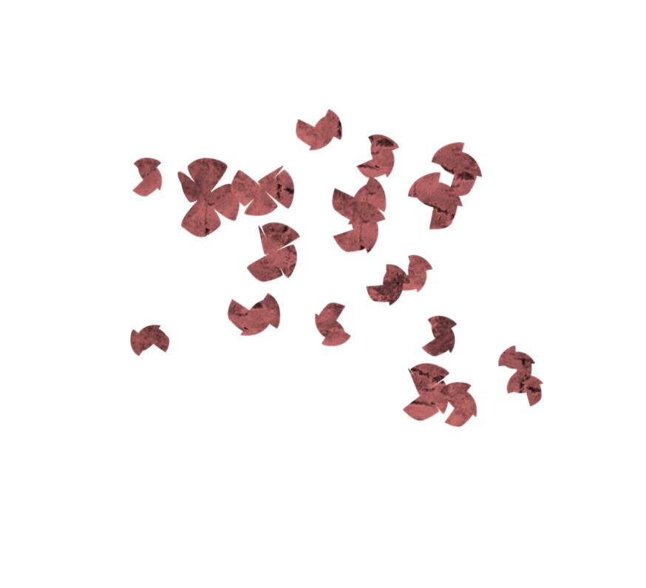
Area 35
for more information contact: Mike Meyer @ meyermike71@gmail.com

Spring Speech Contest
Table Topics and International
March 10, 2016
5:30 pm Dinner and Registration Begins
6:00 pm Briefings
6:30 pm Contest Begins
8:30 pm Contest Concludes
Watertown MN, City Hall
309 Lewis Ave S, Watertown, MN 55388
(Southwest Parking Lot Entrance)
Guests are Welcome

