Area 42 Fall Speech Contest
Table Topics & Humorous Speech

When: Thursday, September 15th, 2016

Where: Heartland Credit Union
5500 S Robert Trl Inver Grove Heights, Minnesota 55077-1445
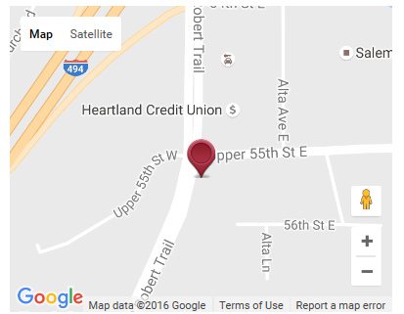

Host Club: Voice of Leadership Club (Club # 3670)

Program: Registration Opens: 5:30 pm
Briefings Begin: 5:45 pm
Contest Starts: 6:00 pm

Cost: Free - Please bring a snack to share

Questions? Please contact:

Carol J. Ullery, Area 42 Director
Email: carol.ullery@bluecrossmn.com
Phone: (952) 807- 4237

Join us for a fun evening!

