Area 54 Fall Speech Contest
Table Topics & Humorous Speech

When: Friday, October 7, 2016

Where: Edwards Hall, Charter House
211, 2nd Street NW, Rochester, MN 55901
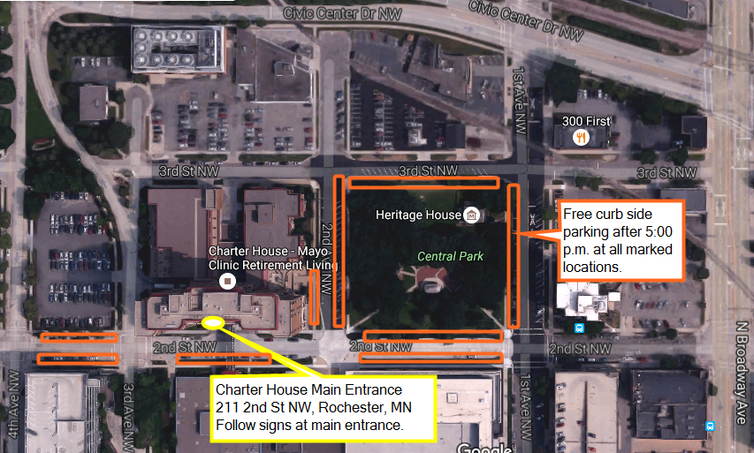

Program: Registration Opens: 5:30 pm
Briefings Begin: 6:00 pm
Contest Start: 6:30 pm
Contest Finishes: 8:30 pm

Cost: Free

Refreshments: Light refreshments will be provided.

Join us for a fun evening!

Questions please contact
Courtney Klapperich
Area 54 Director
cklapperich@gmail.com

