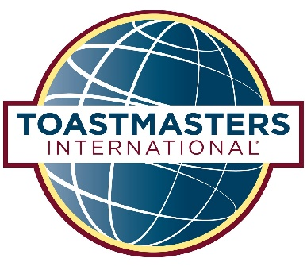

“Discover your Magic”

Magic Happens When you are Outside of your Comfort Zone!

Come and Enjoy the Fun! Everyone is Welcome at this Magic Event!

Area 55 Fall Speech Contest

Humorous and Table Topics Contest

Owatonna Public Library

October 08,2016

105 North Elm Ave., Owatonna, MN 55060

10:00 am – 12:00 pm

Registration beginnings 9:30 am

Please if you have any questions, contact Elsa Esquivel-Soto 507 583-2561 (Contest Chair) or Mary Holtorf haltorfmary@gmail.com (Contest Co-chair).

