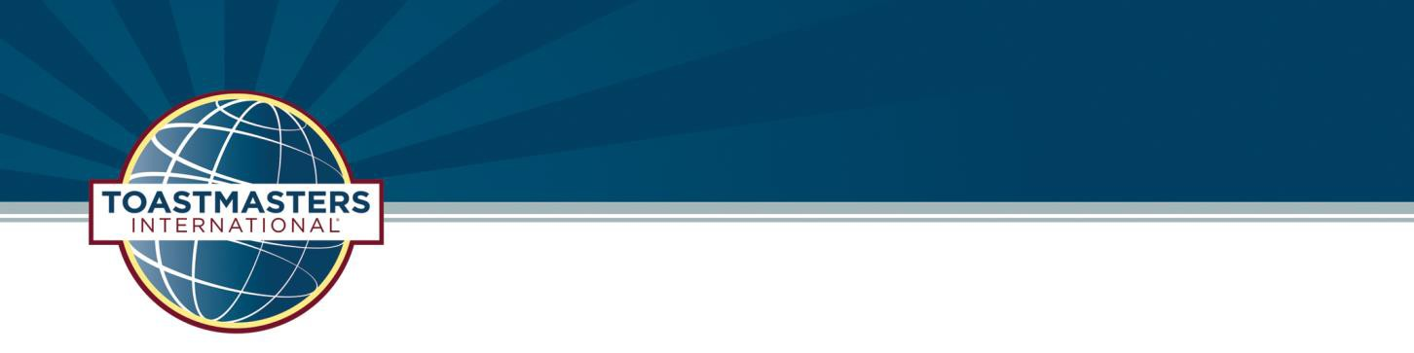
Area 63 and 66
Fall Speech Competition


Thursday, September 14th, 2017
6:00 PM – 8:30 PM
Registration begins at 5:30 PM
Contestant Briefing at 6:00 PM
Contest begins at 6:30 PM
Hennepin County Library
(Brookdale Location)
6125 Shingle Creek Parkway
Brooklyn Center, MN 55430
-Free parking outside the library-

Humorous Speech Contest
Table Topics Contest

Interested in volunteering at the contest? Please contact:
Danielle Tallman at DTallman@BuffaloWildWings.com
or
Lynn Cases at LynnCases@Hotmail.com

