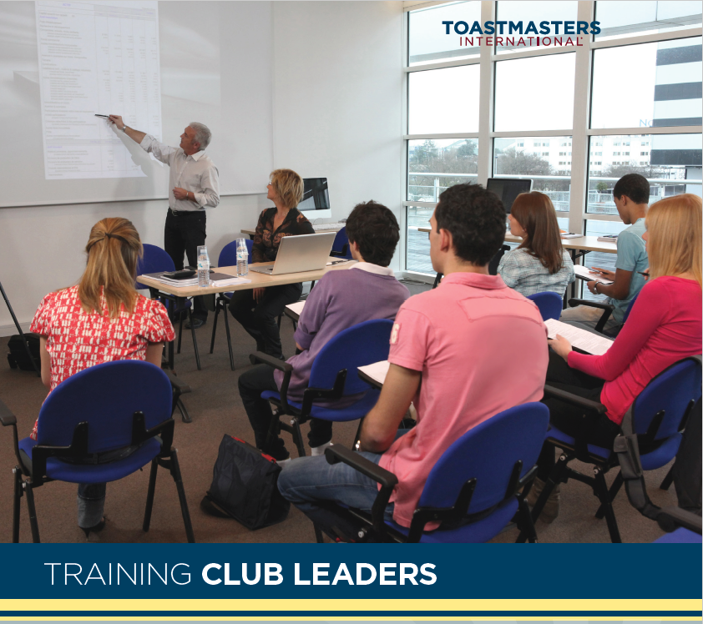
Club officers training
Area 22
Venue: Columbia Heights Library
3939 Central Ave NE, Columbia Heights, MN 55421
Date & Time: Aug 19 @ 1 pm – 2:00 pm
Contact: Courtney Jahnke
Email: coreylovestheater@gmail.com

