Northern Division Fall Speech Contest
Table Topics & Humorous Speech

When: Tuesday, September 24th, 2013

Where: Trusight
9805 45th Ave N
Plymouth, MN 55442

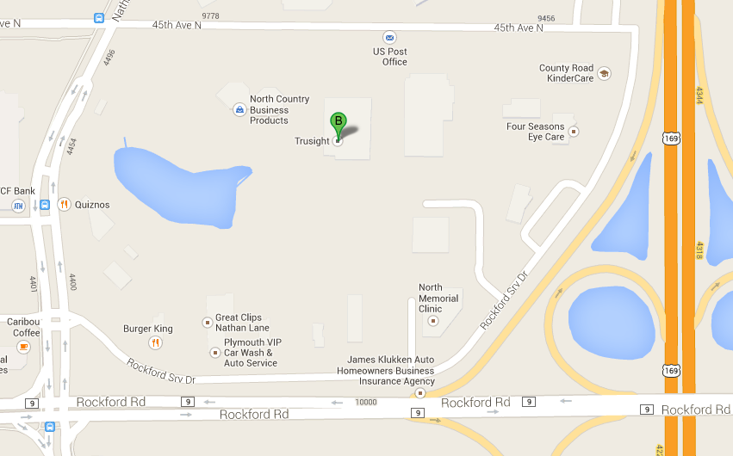

Host Club: Best Sight Speakers (Club # 2188233)

Program: Registration Opens: 6:00 pm
Briefings Begin: 6:30 pm
Contest Starts: 7:00 pm
Contest Finishes: 9:30 pm

Cost: Free

Refreshments: Light dinner will be provided.

RSVP: Harold Osmundson, Northern Division Governor
Email: hosmundson@computer.org
Phone: (763) 213-7795

Join us for a fun evening!

