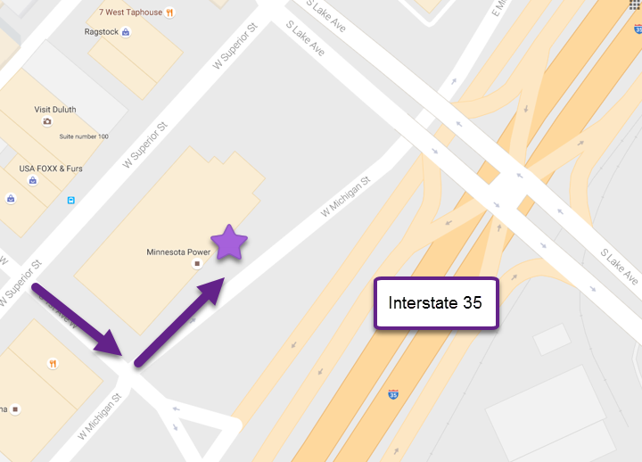
There is a parking ramp located underneath the Minnesota Power building that is accessible from W Michigan St.

To access the ramp and get into the building:
- Drive to the gate and swipe a debit/credit card
  - Parking is free on the weekends, but you still need to swipe a card to get in and out
- Park, then walk to the enclosed entryway located on level C or D. You will be greeted at the door and escorted up to level 1 of the building.

