Judges Helpful Tips Handout
BALLOT:

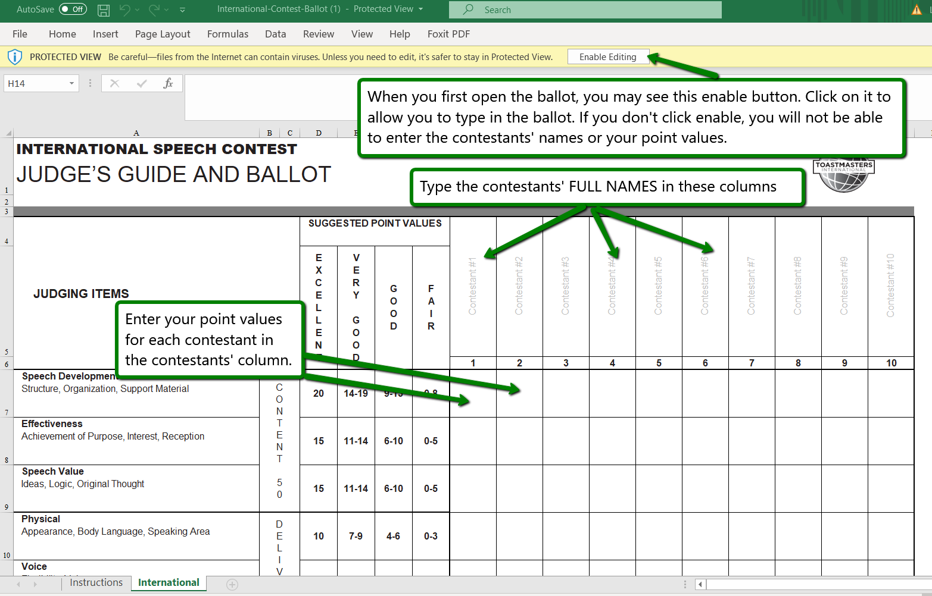

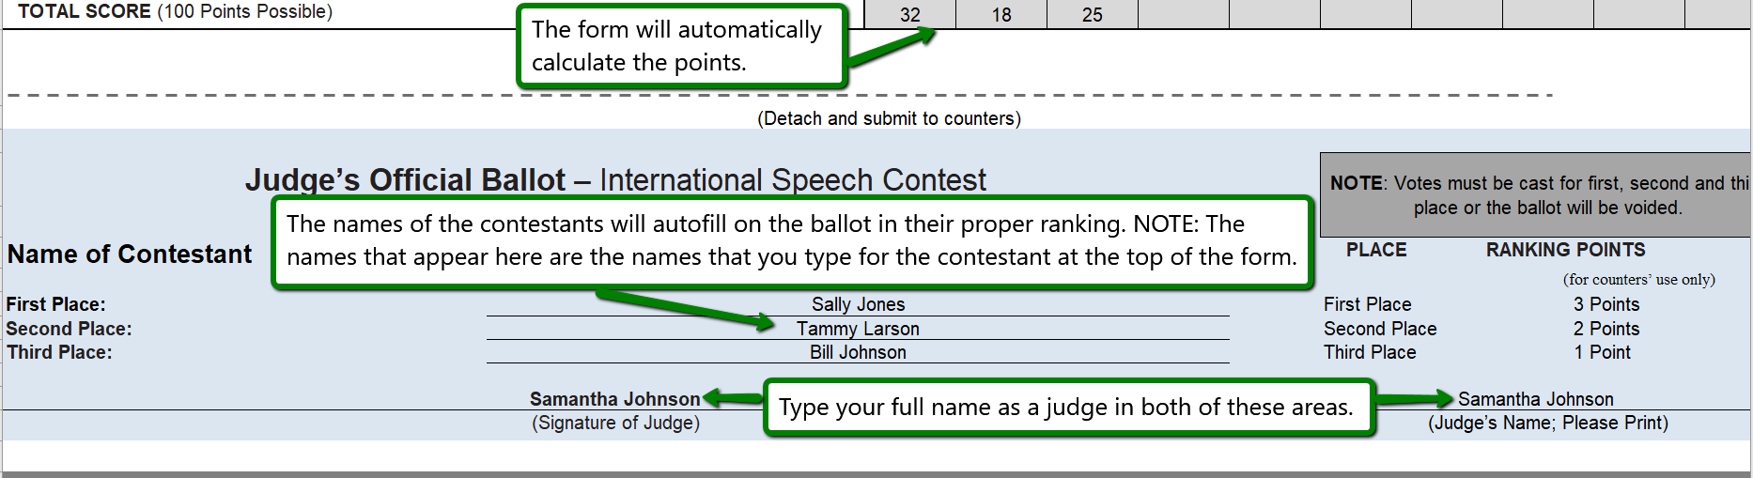

Submit your completed ballot at the end of EACH contest to the Chief Judge and the ballot counters via email or text as instructed by the Chief Judge. See the next page for tips on submitting your ballot.

SUBMITTING YOUR BALLOT:
- If you use Outlook, you may copy the ballot, paste it into Outlook and email to the Chief Judge and ballot counters. OR
- If you use GMAIL, you will need to highlight the ballot, use CTRL C or Right Click and copy to copy the ballot:
  - Open Powerpoint
  - Open a blank presentation
  - Paste the ballot using the PICTURE option for paste. This screens a screen shot.
  - Select the image again from the PowerPoint and copy.
  - Paste into your Gmail email to the Chief Judge and ballot counters. OR
- Alternately, you could use a screen snipping tool or take a photo of this portion of the ballot and email it to the Chief Judge and ballot counters.
- Please delete the email with your ballot after the contest concludes.
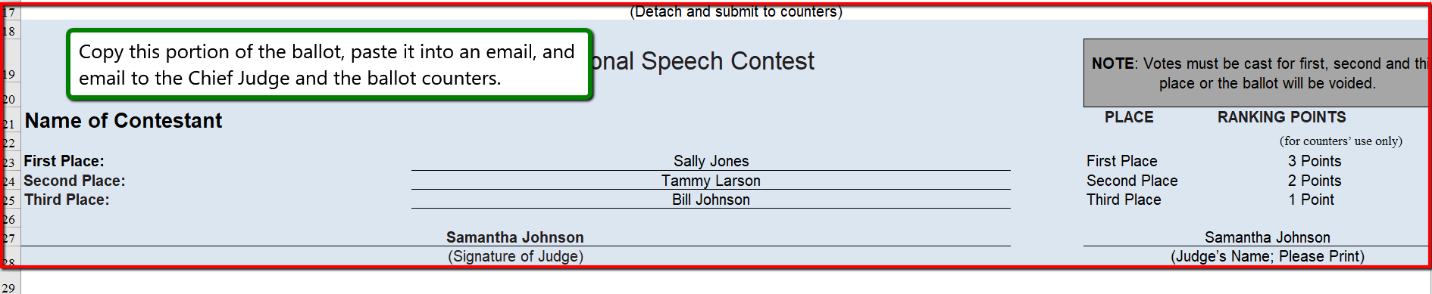

HELPFUL ZOOM TIPS:
- Zoom meeting help: http://www.d6tm.org/wp-content/uploads/How-to-Zoom.docx
- How to test your video: https://support.zoom.us/hc/en-us/articles/201362313-How-Do-I-Test-My-Video-
- How to test your audio: https://support.zoom.us/hc/en-us/articles/201362283-Testing-computer-or-device-audio

As a judge, you will want to use the SWAP ICON to use the SPEAKER VIEW in the upper right corner so you see the contestant in the big screen.
