
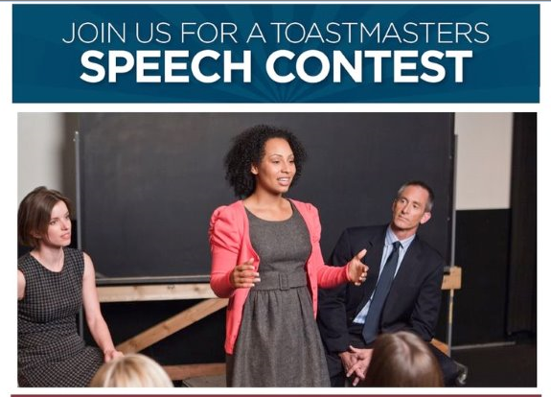

Area 17 Speech Contest
Tall Tales and International Speech

Date: Thursday March 8, 2018
Where: Brookdale Public Library
6125 Shingle Creek Pkwy, Brooklyn Park, MN

Time: Speakers & Volunteers arrive at 6:00pm for instructions
Contest begins at 6:30 pm
Wrap Up: 8:30pm

Contact: Roberta Hooyman
E-mail: BLHOOY@aol.com

Area 17 Speech Contest
Humorous & Table Topics

Date: Thursday October 11, 2017
Where: Brookdale Public Library
6125 Shingle Creek Pkwy, Brooklyn Park, MN

Time: Speaker & Volunteers arrive at 6:00pm
Contest begins at 6:30 pm
Wrap Up: 8:30pm -8:45pm

Contact: Roberta Hooyman
E-mail: BLHOOY@aol.com

