D
o you remember the first time you realized that the spoken word had power? Was it when you were small and asked someone to be your friend, and they said yes?
Or, maybe someone used words to hurt you and your mom said, “Sticks and stones will break your bones but words will never hurt you.” You knew that wasn’t true.

Or, maybe, like me, you found by accident. Words just came out of your mouth and people reacted.

This is me at three.
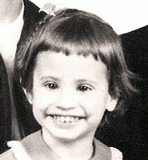
Big teeth.
Big smile.
Bad hair day.
Some things never change!

However, one thing that did change for me at three was that I began to realize the power of the spoken word.

My mother had brought me to work to meet her boss and coworkers. One look at her boss and I was in awe. She was just about the ugliest woman I had ever seen—long pointy chin, hooked nose, dark, bushy eyebrows over beady eyes. I blurted out, “Mommy! She looks like the Wicked Witch of the West!” Suddenly, there was complete silence. Wow. I had made quite an impression!
My mother turned to me and said, “Diane, don’t you mean, Glenda the Good Witch?”

Hello? Did my mother just lose her mind? “No. Glenda was pretty!”

Fortunately, my mother’s boss started laughing and all was well. And I had found a new power—the power of words.

But as I got older, the power weakened, dimmed by the lack of self-confidence that can occur during the teen years.

As I entered the work force as a woman engineer, I paid more attention to my abilities to calculate than to my abilities to converse.

Later, as a stay-at-home parent, I began to feel that I was becoming invisible and didn’t have much to say. I was losing my voice.

I can thank Toastmasters for helping me find my voice.

When I visited a Toastmasters club in late 2003, I didn’t know that Toastmasters would lead to a new career path. I didn’t know that Toastmasters would lead me to some of my best friends. I didn’t know that Toastmasters would not only make me a better speaker, but also a better leader.

I’d like to tell you that my joining Toastmasters was part of a bigger plan for my life—a powerful plan for powerful words—but it wasn’t—well, maybe it was—it just wasn’t my plan.

When I first visited a club, I wasn’t looking to become a polished speaker or to enhance my leadership skills. I was just looking for a club that would allow my homeschooled, teenaged son to participate, even though he was too young to join. They welcomed his participation, on one condition—I had to join the club!

I joined the club and the next week, I was in a leadership position, as educational vice president, helping to plan club meetings. Over the past few years I have held several club and district leadership positions, greatly improving both my management and leadership skills—“on-the-job” leadership training in the non-threatening and supportive environment that is a hallmark of Toastmasters.

In addition to growing in leadership skills, I grew in communication skills through the various projects emphasizing different aspects of communication from the basics of organizing a speech to the challenges of leading discussions.
Find a Toastmasters Club near you:
http://reports.toastmasters.org/findaclub

I was finding my voice again—rediscovering the power of words.

And I also found the best kinds of friends—the encouraging kind!

It was with the encouragement of other Toastmasters that I began to consider developing myself as a professional speaker.

I found my voice.

Toastmasters can help you find yours.

If you’d like to know more about my story or about Toastmasters, feel free to contact me:

Diane Windingland
ToastmasterDiane@aol.com
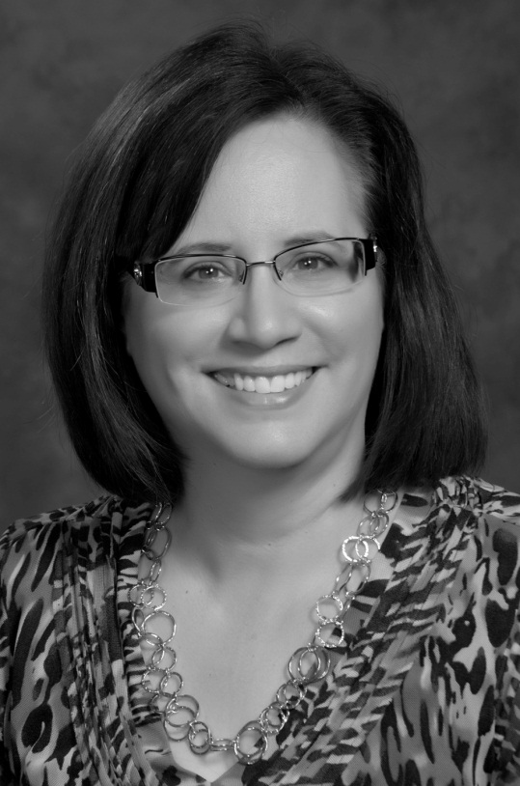

Finding My Voice

