District 6
A Message from our Club Growth Director

Dear Future Toastmaster,
Thank you for attending this meeting. Whether you found us by searching online, through your company, or from a friend—welcome! At Toastmasters we believe in providing our guests and members with a positive and supportive environment to ensure everyone has a safe space to learn and grow. In fact, it’s a vital part of our Club Mission:
We provide a supportive and positive learning experience in which members are empowered to develop communication and leadership skills, resulting in greater self-confidence and personal growth.
I immediately felt welcomed when I visited my first Toastmasters meeting and joined shortly thereafter. I became a Toastmaster in January of 2017 because I wanted to become a better public speaker, but I found so much more. The educational program provided a great learning opportunity for me to explore and practice presentation skills that helped me in my career and everyday life. Mentors cheered me on and helped me navigate various ways to become a better speaker—they also provided opportunities for me to grow in my leadership skills. I have also met fascinating people in Toastmasters who have become dear friends. I am so grateful that I joined Toastmasters. I hope you will, too!
Your Toastmasters journey begins by saying yes to becoming a member. After you join, your fellow Toastmasters will help you learn about our meeting roles and how they provide a chance for you to practice speaking in public, assist you in selecting an education program that allows you to focus on the topics and skills most meaningful to you, guide you as you work on your first speech called the Icebreaker, and provide a supportive evaluation to help you grow as a Toastmaster. You will find that over time, and through participating in your club on a regular basis, you will grow in myriad ways.
As a Toastmaster, you will learn skills that are vital in the workplace and in everyday life, such as time management, active listening, providing feedback, creating a message that is organized, and skills to engage an audience when you speak.
I invite you to join me along with 358,000 Toastmasters worldwide to invest in yourself to become a better speaker and leader.
Warm regards,
Linda
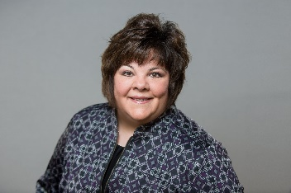
Linda Dorn
Club Growth Director
District 6
linda.dorn@d6tm.org
612-889-8932
Where Leaders Are Made

